# 

# Experiment 10 : To find DFT & IDFT of given DT signals using FFT

Aim : To write the matlab code to determine DFT/IDFT of a given signal.

**Run #01:**

(1) Find the circular convolution for the given DT signals using matlab.

x(n) = [2, 1, 2, 1] and h(n) = [1, 2, 3, 4].

Write Matlab code using Matlab built-in functions fft & ifft.

|  |
| --- |
| >> x = [2 1 2 1];  >> h = [1 2 3 4];  >> cconv(x,h,4)  ans =  14 16 14 16  **OR**  x = [2 1 2 1];  y = [1 2 3 4];    ccirc = ifft(fft(x).*fft(y))  ccirc =  14 16 14 16 |

Run#02

(2)

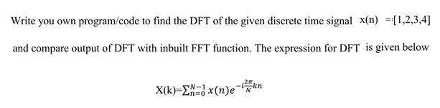

(Hint: use for loop)

|  |
| --- |
| N = 4;  x = [1 2 3 4];  X = zeros(N,1);  for k = 1:N  X(k) = 0;  for n = 1:N  X(k) = X(k)+(x(n)*exp((-1j)*2*pi*(n-1)*(k-1)/N));  end  end    disp(X);    %Calculating using DFT using the fft command  fft(x)  Ans:  With the manually written code:  10.0000 + 0.0000i  -2.0000 + 2.0000i  -2.0000 - 0.0000i  -2.0000 - 2.0000i  With the fft command  ans =  10.0000 + 0.0000i -2.0000 + 2.0000i -2.0000 + 0.0000i -2.0000 - 2.0000i |

Run#03:

(3) Show that equivalence between linear and circular convolution for the given sequences :

x[n] = [6, 4, 3, 7, 8] and h[n] = [1, 2, 3, 4]

Use the “conv” command for linear convolution and “cconv” (or) FFT command for

circular convolution.

Plot both the signals using stem function and compare the results obtained.

Ans:

x = [6 4 3 7 8];

y = [1 2 3 4];

clin = conv(x,y);

xpad = [x zeros(1,8-length(x))];

ypad = [y zeros(1,8-length(y))];

ccirc = ifft(fft(xpad).*fft(ypad));

subplot(2,1,1)

stem(clin,'filled')

ylim([0 75])

title('Linear Convolution of x and y')

subplot(2,1,2)

stem(ccirc,'filled')

ylim([0 75])

title('Circular Convolution of xpad and ypad')

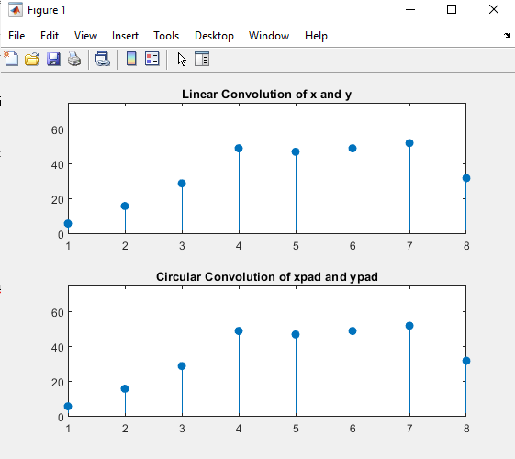

**Last Date of Submission : 15-04-2021(Thursday)**

Both Tuesday and Thrusday lab section students submit your reports in this google link https://forms.gle/8w78LHHarTHR9uwe9